**Parity Detector**

**Lab no# 10**



Spring 2022

CSE-308L Digital Systems Design lab

Submitted by: **Ashfaq Ahmad**

Registration No: **19PWCSE1795**

Class Section: **B**

“On my honor, as student of University of Engineering and Technology, I have neither given nor received unauthorized assistance on this academic work.”

Student Signature: ______________

Submitted to:

**Dr: Ma’am Madeha sheer**

**July** 24, 2022

**Department of Computer Systems Engineering**

**University of Engineering and Technology, Peshawar**

**Objective:**

* Built a parity detector.

**Parity Detector:**

It is a logic circuit that checks for possible errors in the transmission. This circuit can be an even parity checker or odd parity checker depending on the type of parity generated at the transmission end.

**Odd Parity detector:**

If the total number of 1s in the data is odd, then it indicates no error, whereas if the total number of 1s is even then it indicates the error since the data is transmitted with odd parity at transmitting end.

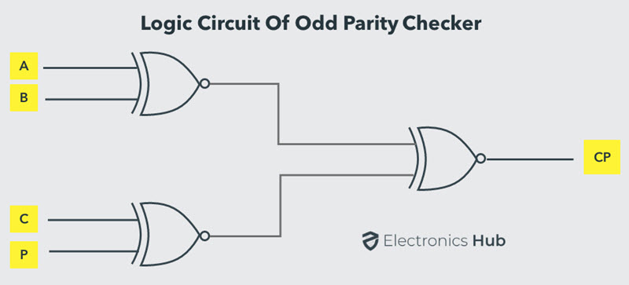

**Even Parity detector:**

If the total number of 1s in the data is even, then it indicates no error, whereas if the total number of 1s is odd then it indicates the error since the data is transmitted with even parity at transmitting end.

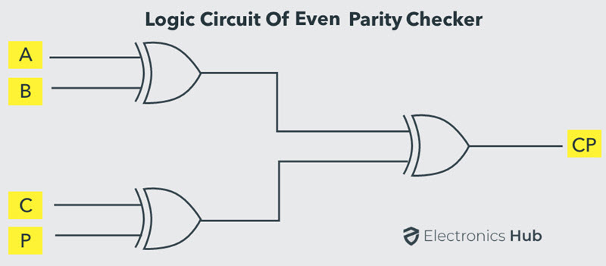

**Task01: Design a Parity Detector.**

**Note:** in this task we designed a code for both even and odd parity. In even case even led on and

In odd case odd led on. We can also design individually even or odd parity detector.

**State Transition Diagram:**

**Moore Machine with two input, zero for 0 and one for 1:**

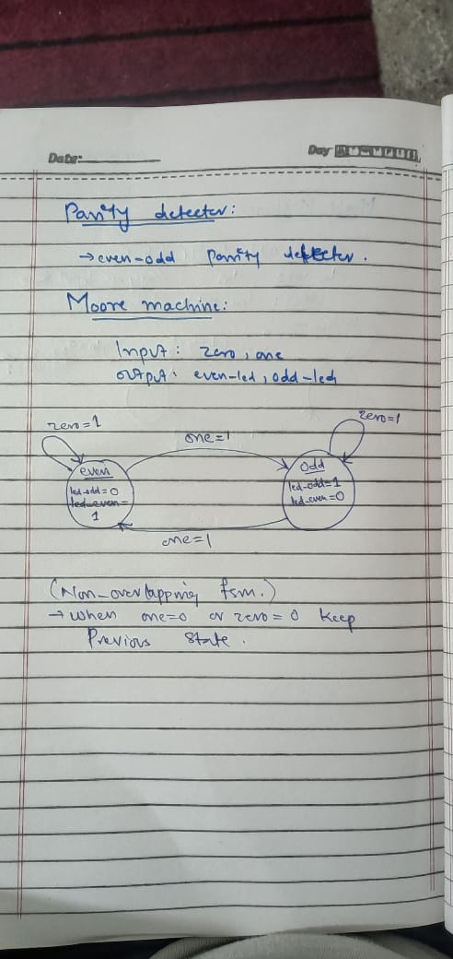

**Transition table**

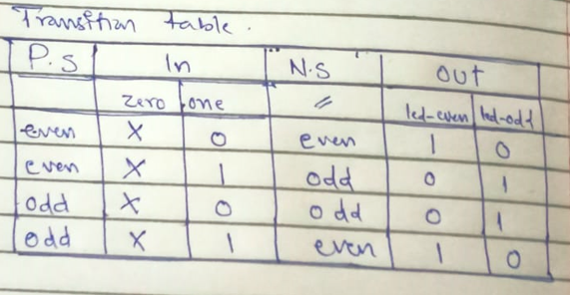

**Mealy Machine with one input set for 1 and reset for 0:**

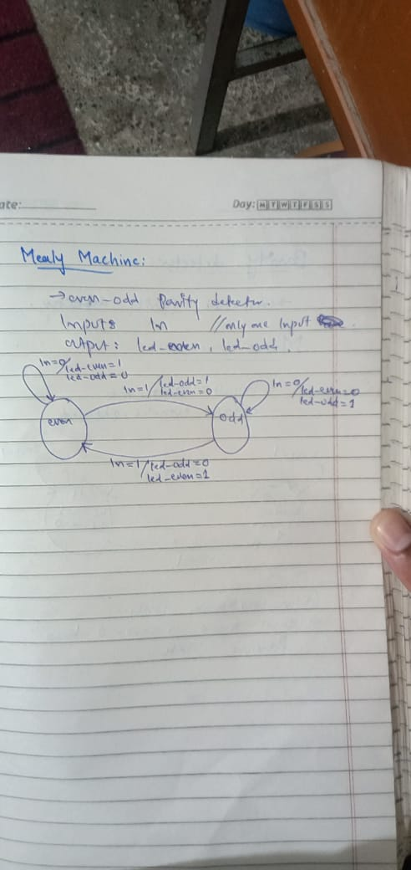

**Transition table:**

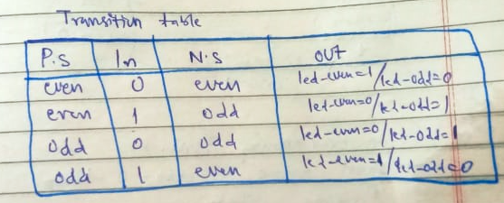

**Source Code: (Two always block and two inputs button (one for 0 and other for 1))**

**Moore Machine:**

module parity_detector(led_even,led_odd,zero,one,clk_100Mhz,reset);

input zero,one,clk_100Mhz,reset;  //two inputs button

output reg led_even,led_odd;

wire clk_1hz,sync_zero,sync_one,l2p_zero,l2p_one;

parameter even=1'b0,odd=1'b1;

reg state,next_state;

clk_divider cd(clk_1hz,clk_100Mhz,reset);  //all module take clk_ihz.

synchronizer syn1(sync_zero,zero,clk_1hz,reset);

synchronizer syn2(sync_one,one,clk_1hz,reset);

l2p l2p1(l2p_zero,sync_zero,clk_1hz,reset);

l2p l2p2(l2p_one,sync_one,clk_1hz,reset);

always @(posedge clk_1hz,posedge reset)

        if(reset)

                  state=even;

           else

                   state=next_state;

always @(*)          //moore machine.

        case(state)

          even:

          begin

               led_even=1;

                 led_odd=0;

                 if(l2p_zero) //if we have two inputs then we can't use ternary operator like (next_state=in?even:odd)

                        next_state=even;

                 else if(l2p_one)

                        next_state=odd;

                 else

                        next_state = state;

          end

          odd:

          begin

               led_odd=1;

                 led_even=0;

                 if(l2p_zero)

                    next_state=odd;

                 else if(l2p_one)

                    next_state=even;

                 else

                    next_state = state;

          end

        default:  //if initially not reset then default statement will execute.

          begin

             led_odd=0;

             led_even=0;

             next_state=even;

        end

        endcase

endmodule

module clk_divider(clk_1hz,clk_100Mhz,reset);

input clk_100Mhz,reset;

output reg clk_1hz;

integer c;

always @(posedge clk_100Mhz)

       if(reset)

         begin

                 clk_1hz=1;

                    c=0;

         end

         else

         begin

             c=c+1'b1;

              if(c==10000000)

              begin

              clk_1hz=~clk_1hz;

              c=0;

              end

         end

endmodule

module synchronizer(out,in,clk_1hz,reset);  //we can also design synchronizer using D_FFs.

input in,clk_1hz,reset;

output reg out;

reg FF1_out;

always @(posedge clk_1hz)

        if(reset)

                  out=0;

          else

          begin

                  FF1_out=in;

                     out=FF1_out;

          end

endmodule

module l2p(l2p_out,sync_in,clk_1hz,reset);

input sync_in,clk_1hz,reset;

output reg l2p_out;

parameter s0=1'b0,s1=1'b1;

reg state,next_state;

always @(posedge clk_1hz)

        if(reset)

          state=s0;

          else

          state=next_state;

always @(*)          //Mealy machine.

        case(state)

          s0:

          begin

             l2p_out=sync_in?1'b1:1'b0;   //as there is only one input so we can use ternary operator.

              next_state=sync_in?s1:s0;

          end

          s1:

          begin

             l2p_out=sync_in?0:0;

              next_state=sync_in?s1:s0;

          end

       default:

         begin

              l2p_out=0;

                next_state=s0;

         end

       endcase

endmodule

**Output: (Moore output)**

* The input Pins are Dip switch no 1 for 0 input and Dip switch no 2 for 1 input and reset switch is dip switch no 8.
* States are Even and odd.
* Led no 1 is even output and led no 2 is odd output.

**State:** even;

**Output:** even_led=1, odd_led=0;

**Input:**  zero=0, one=1;

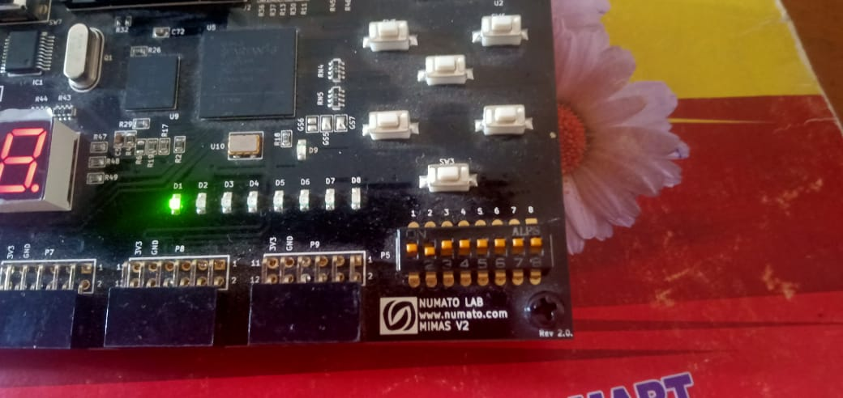

**State:** odd;

**Output:** even_led=0, odd_led=1;

**Input:**  zero=0, one=1;

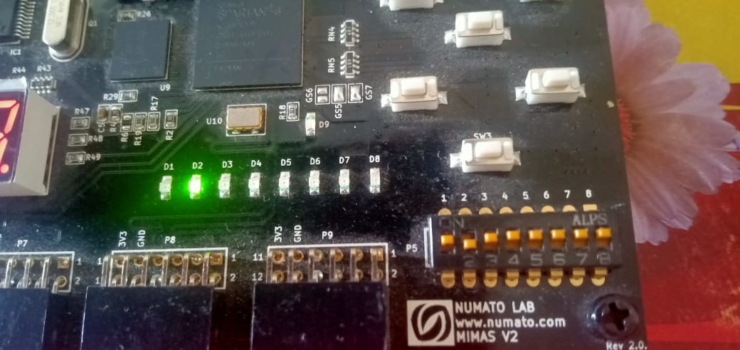

**Reset case:**

**Output:** even led=1;

**State:**  even;

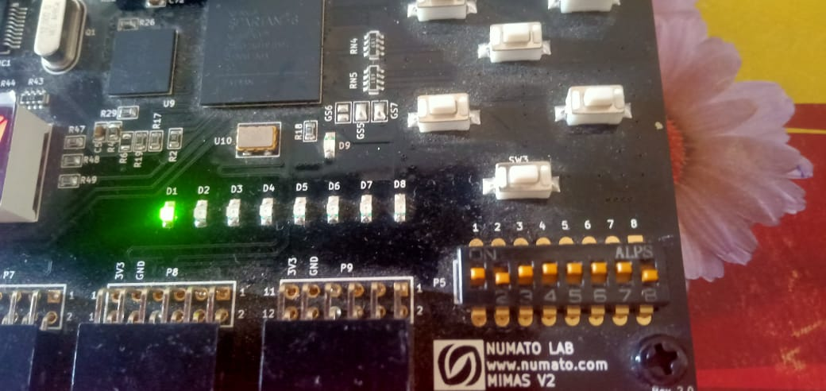

**UCF file:**

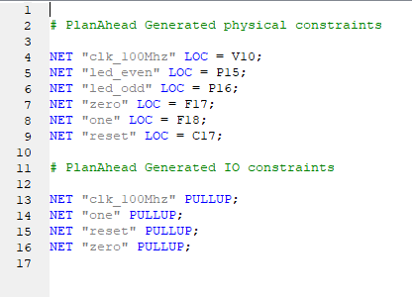

**Mealy Code: (one always block and one inputs button (set for 1 and reset for 0))**

module parity_detector(led_even,led_odd,in,clk_100Mhz,reset);  //one input

input in,clk_100Mhz,reset;

output reg led_even,led_odd;

wire clk_1hz,sync_out,l2p_out;

parameter even=1'b0,odd=1'b1;

reg state;

clk_divider cd(clk_1hz,clk_100Mhz,reset);

synchronizer sync(in,sync_out,clk_1hz,reset);

l2p lp(l2p_out,sync_out,clk_1hz,reset);

always @(posedge clk_1hz,posedge reset)  //one always block .....Mealy Machine

        if(reset)

          begin

                  state=even;

                     led_even=1'b1;

                     led_odd=1'b0;

          end

          else

        case(state)

          even:

          begin

               led_even=l2p_out?1'b0:1'b1;   //as one input so ternary operator.

                 led_odd=l2p_out?1'b1:1'b0;

                 state=l2p_out?odd:even;

          end

          odd:

          begin

               led_even=l2p_out?1'b1:1'b0;

                 led_odd=l2p_out?1'b0:1'b1;

                 state=l2p_out?even:odd;

          end

          default:

          begin

               state=even;

                 led_even=1'b1;

                 led_odd=1'b0;

          end

        endcase

endmodule

module clk_divider(clk_1hz,clk_100Mhz,reset);  //clock divider

input clk_100Mhz,reset;

output reg clk_1hz;

integer c;

always @(posedge clk_100Mhz)

       if(reset)

         begin

                 clk_1hz=1;

                    c=0;

         end

         else

         begin

             c=c+1'b1;

              if(c==10000000)

              begin

              clk_1hz=~clk_1hz;

              c=0;

              end

         end

endmodule

module D_FF(in,out,clk_1hz,reset);   //D_FF

input in,clk_1hz,reset;

output reg out;

always @(posedge clk_1hz)

        if(reset)

                out=0;

        else

            out=in;

endmodule

module synchronizer(in,sync_out,clk_1hz,reset);   //synchronizer

input in,clk_1hz,reset;

output sync_out;

wire FF1_out;

D_FF dff1(in,FF1_out,clk_1hz,reset);

D_FF dff2(FF1_out,sync_out,clk_1hz,reset);

endmodule

module l2p(l2p_out,sync_in,clk_1hz,reset);    //l2p

input sync_in,clk_1hz,reset;

output reg l2p_out;

parameter s0=1'b0,s1=1'b1;

reg state,next_state;

always @(posedge clk_1hz)

        if(reset)

          state=s0;

          else

          state=next_state;

always @(*)          //Mealy machine.

        case(state)

          s0:

          begin

             l2p_out=sync_in?1'b1:1'b0;   //as there is only one input so we can use ternary operator.

              next_state=sync_in?s1:s0;

          end

          s1:

          begin

             l2p_out=sync_in?0:0;

              next_state=sync_in?s1:s0;

          end

       default:

         begin

                l2p_out=0;

                next_state=s0;

         end

       endcase

endmodule

**UCF File:**

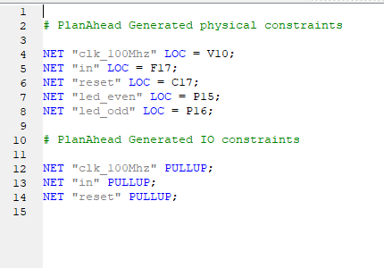

**Output: (Mealy output)**

* The Dip switch no 1 is input switch and reset switch is dip switch no 8.
* States are even and odd

Initially

**State:** even

**Reset=**0

**Input:** in=0;

**Output:** led even=1, led odd=0;

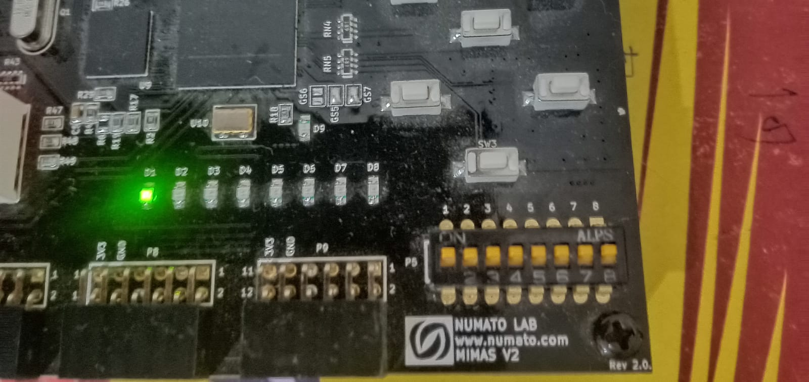

**State:** odd

**Reset=**0

**Input:** in=1;

**Output:** led even=0, led odd=1;

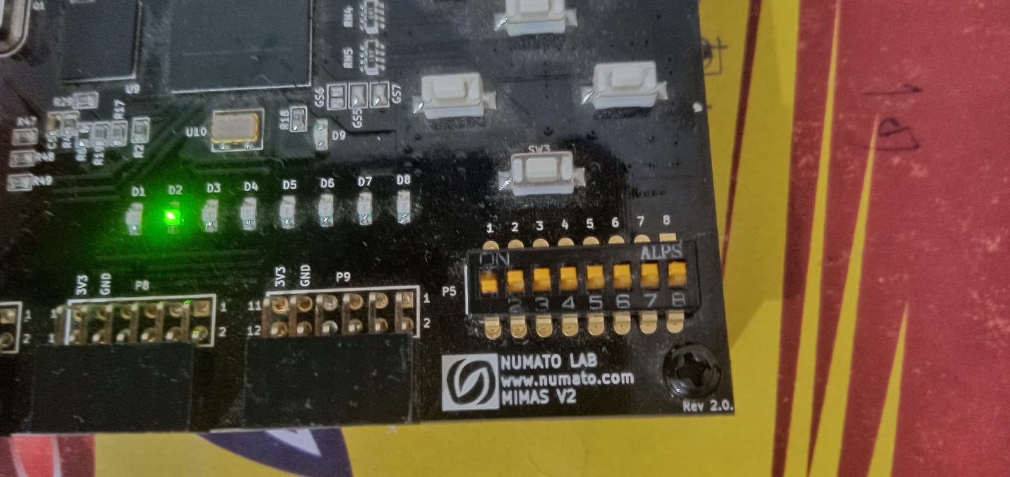

**State:** odd

**Reset=**0

**Input:** in=0;

**Output:** led even=0, led odd=1;

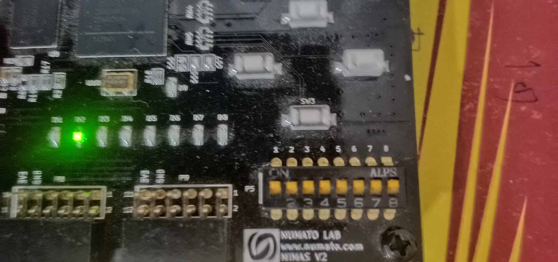

**State:** even

**Reset=**0

**Input:** in=1;

**Output:** led even=1, led odd=0;

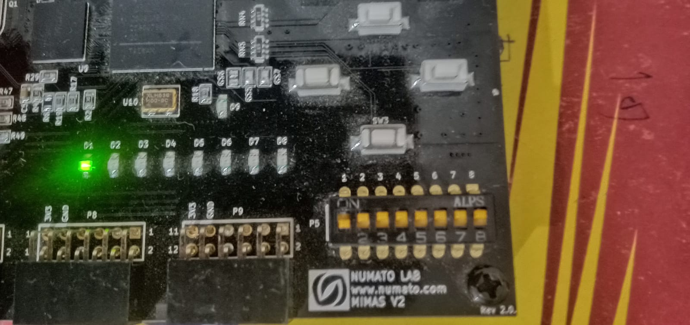

**Reset case:**

**Reset=1;**

**Output:** even led=1;

**State:**  even;

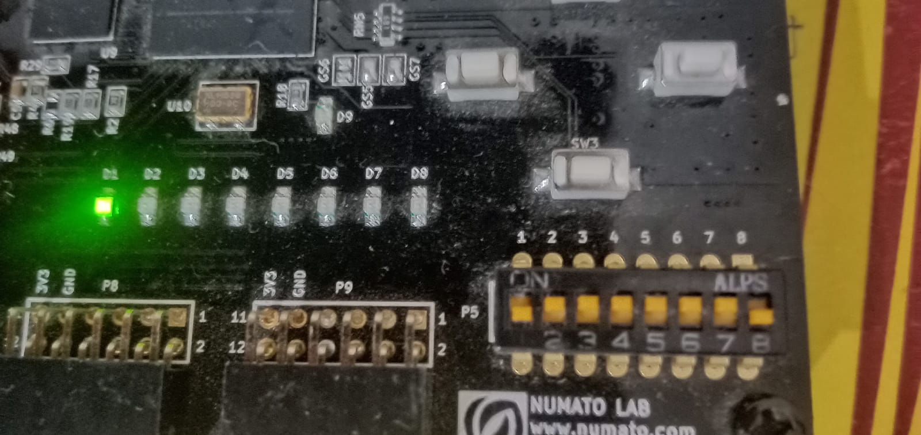

**Above Code without synchronizer and L2P converter.**

If we don’t use synchronizer and l2p converter and keep input as high then output (even led odd led) will toggle continuously. Because at each clock cycle the no of 1’s increment. In even case even led on and in odd case odd led on.

**Code:**

module parity_detector(led_even,led_odd,in,clk_100Mhz,reset);

input in,clk_100Mhz,reset;

output reg led_even,led_odd;

wire clk_1hz;

parameter even=1'b0,odd=1'b1;

reg state,next_state;

clk_divider cd(clk_1hz,clk_100Mhz,reset);

always @(posedge clk_1hz,posedge reset)

        if(reset)

                  state=even;

           else

                   state=next_state;

always @(*)

        case(state)

          even:

          begin

               led_even=1;

                 led_odd=0;

                 next_state=in?odd:even;

          end

          odd:

          begin

               led_odd=1;

                 led_even=0;

                 next_state=in?even:odd;

          end

        endcase

endmodule

module clk_divider(clk_1hz,clk_100Mhz,reset);

input clk_100Mhz,reset;

output reg clk_1hz;

integer c;

always @(posedge clk_100Mhz)

       if(reset)

         begin

                 clk_1hz=1;

                    c=0;

         end

         else

         begin

             c=c+1'b1;

              if(c==10000000)

              begin

              clk_1hz=~clk_1hz;

              c=0;

              end

         end

endmodule